**Military College of Signals**

**CS Department**

**Automata Theory and Formal Languages**

**Spring 2011 BESE 14**

**Assignment 02 – NFA to DFA**

**Due date: *15th Mar, 2011***

**Q1:** Convert the NFA given in Table 1 to DFA. The start state is q0 and the final state is q3.

Table 1

|  |  |  |  |
| --- | --- | --- | --- |
|  | **0** | **1** | **λ** |
| **q0** | q0 | q0, q1 | - |
| **q1** | q2 | - | q2 |
| **q2** | - | q3 | - |
| **q3** | q3 | q3 | - |

**Q2:** Convert the NFA given in Table 2 to DFA. The start state is A and the final state is D.

Table 2

|  |  |  |
| --- | --- | --- |
|  | **0** | **1** |
| **A** | A, C | A, B |
| **B** | C | B |
| **C** | B, C | D |
| **D** | D | D |

**Q3:** Convert the NFA given in Figure 1 to DFA.

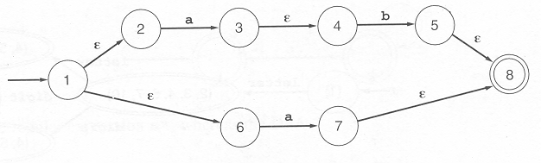

Figure 1

**Q4:** Convert the NFA given in Figure 2 to DFA.

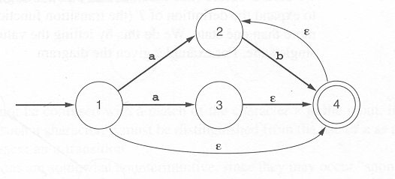

Figure 2